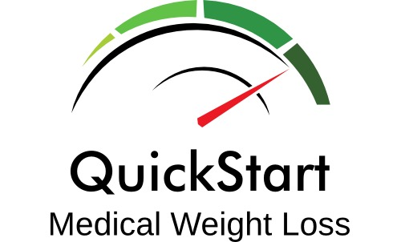

Weight Loss Program Consent Form

I ___________________________ authorize Dr. Roman Bautista and whomever he designates as his assistants, to help me in my weight reduction efforts. I understand that my program may consist of a balanced deficit diet, a regular exercise program, instruction in behavior modification techniques, and may involve the use of appetite suppressant medications. Other treatment options may include a very low calorie diet, or a protein supplemented diet. I further understand that if appetite suppressants are used, they may be used for durations exceeding those recommended in the medication package insert. It has been explained to me that these medications have been used safely and successfully in private medical practices as well as in academic centers for periods exceeding those recommended in the product literature.

I understand that any medical treatment may involve risks as well as the proposed benefits. I also understand that there are certain health risks associated with remaining overweight or obese. Risks of this program may include, but are not limited to: nervousness, sleeplessness, headaches, dry mouth, gastrointestinal disturbances, weakness, tiredness, psychological problems, high blood pressure, rapid heartbeat, and heart irregularities. These and other possible risks could, on occasion, be serious or even fatal. Risks associated with remaining overweight are tendencies to: high blood pressure, diabetes, heart attack, heart disease, arthritis of the hips, knees, feet and back, sleep apnea, and sudden death. I understand that these risks may be modest if I am not significantly overweight, but will increase with additional weight gain.

I understand that much of the success of the program will depend on my efforts and that there are no guarantees or assurances that the program will be successful. I also understand that obesity may be a chronic, life-long condition that may require changes in eating habits and permanent changes in behavior to be treated successfully.

As this program involves appetite suppressant medications, the medication is provided to the medically qualifying patient at the time of examination. The patient understands that he/she may choose instead to obtain a written prescription for the medication to be filled at a pharmacy of his/her choice.

FINANCIAL POLICY
Please be advised that payment for all services will be due at the time services are rendered. For your convenience we accept Visa, MasterCard, American Express, Discover and cash payments.

RECEIPT OF NOTICE OF PRIVACY PRACTICES WRITTEN ACKNOWLEDGEMENT
I have received/reviewed a copy of the QuickStart Medical Weight Loss Notice of Privacy Practices and the Florida Patient Bill of Rights.

I have read and fully understand this consent form and I realize I should not sign this form if all items have not been explained to me. My questions have been answered to my complete satisfaction.

Date:_________________________ Time:_______________________

Patient:______________________________ Witness:_____________________________

